- Create a customized Docker image using a Dockerfile.
- Push the image to Docker Hub.
- Push the same image to Amazon ECR.
- Provision one EC2 instance using Terraform and install Jenkins.
- Create one Jenkins job to build and push the Docker image to Docker Hub.
  - Source: https://github.com/betawins/Python-app.git
 Source Codes: https://github.com/betawins/docker-tasks.git
- From the frontend source code, write a Dockerfile, build a Docker image, run it, and push that image to your Docker registry.
- From the Java-based source code, write a Dockerfile, build, run, and push the image to the Docker registry.
- From the Node.js-based source code, write a Dockerfile, build with tag v1, run, and push it to the Docker registry.
- Write a docker-compose file to set up WordPress with a MySQL database.

1. Create a customized Docker image using a Dockerfile.

Create a Project Directory
Create an isolated directory on your system to hold your Docker build files and navigate into it:
Bash
mkdir -p ~/custom-web-image && cd ~/custom-web-image

- Verification: Run pwd to ensure you are in /root/custom-web-image (or your user's home folder).

2. Create the Application Files
Create a custom HTML page and a configuration file to serve through the image:
Bash
cat << 'EOF' > index.html
<!DOCTYPE html>
<html lang="en">
<head>
<meta charset="UTF-8">
<title>Custom Docker Container</title>
<style>
body { font-family: sans-serif; background: #0f172a; color: #f8fafc; text-align: center; padding: 4rem; }
h1 { color: #38bdf8; }
</style>
</head>
<body>
<h1>Custom Docker Image Running Successfully!</h1>
<p>Built using a multi-instruction Dockerfile on Alpine Linux.</p>
</body>
</html>
EOF

- Verification: Run ls to confirm index.html exists.

3. Write the Dockerfile
Create a customized Dockerfile incorporating standard Dockerfile instructions (FROM, LABEL, ENV, WORKDIR, RUN, COPY, EXPOSE, HEALTHCHECK, and CMD):
Bash
cat << 'EOF' > Dockerfile
# Base image: minimal Alpine Linux with Nginx
FROM nginx:alpine

# Metadata labels
LABEL maintainer="admin@example.com"
LABEL description="Customized Nginx Web Application"
LABEL version="1.0"

# Set environment variables
ENV APP_ENV=production \
PORT=80

# Set the working directory inside the container
WORKDIR /usr/share/nginx/html

# Run system commands inside the image during build
RUN rm -rf ./* && \
apk update && \
apk add --no-cache curl

# Copy local application code into the image
COPY index.html .

# Expose network port
EXPOSE 80

# Health check to ensure the service stays healthy
HEALTHCHECK --interval=30s --timeout=3s --retries=3 \
CMD curl -f http://localhost/ || exit 1

# Default process executed when starting the container
CMD ["nginx", "-g", "daemon off;"]
EOF

- Instruction Breakdown:
  - FROM: Specifies the foundational base image.
  - LABEL: Adds metadata key-value pairs.
  - ENV: Sets environment variables accessible during runtime.
  - WORKDIR: Creates and sets the active working directory for subsequent instructions.
  - RUN: Executes shell commands to install packages or modify files during the build phase.
  - COPY: Transfers local files into the container's filesystem.
  - EXPOSE: Documents which network port the application listens on.
  - HEALTHCHECK: Defines how Docker tests whether the container is healthy.
  - CMD: Specifies the executable command that runs when the container launches.
- Verification: Run cat Dockerfile to verify the configuration syntax.

4. Build the Docker Image
Run docker build to compile the instructions into a new container image:
Bash
docker build -t custom-web-app:1.0 .

- Command breakdown:
  - -t custom-web-app:1.0: Assigns a name and tag to the image.
  - .: Sets the current directory as the build context.
- Verification:
- Bash
docker images | grep custom-web-app

- You should see custom-web-app with the tag 1.0 in the output list.

5. Run and Test the Container
Run a container instance from your newly customized image:
Bash
docker run -d --name my-custom-app -p 8085:80 custom-web-app:1.0

- Command breakdown:
  - -d: Runs the container in the background (detached mode).
  - --name my-custom-app: Names the active container instance.
  - -p 8085:80: Forwards port 8085 on your host machine to port 80 inside the container.

6. Verify Container Execution
- Check runtime status:
- Bash
docker ps -f name=my-custom-app

- Expected output: Status should show Up and (healthy).
- Test the HTTP response:
- Bash
curl -s http://localhost:8085 | grep "Custom Docker Image Running Successfully!"

- Expected output: Prints the matching HTML header text confirming the custom index.html was served.

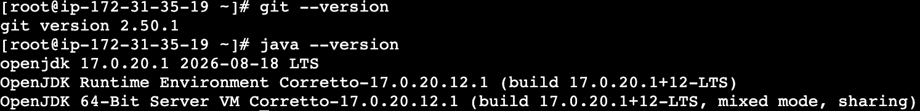

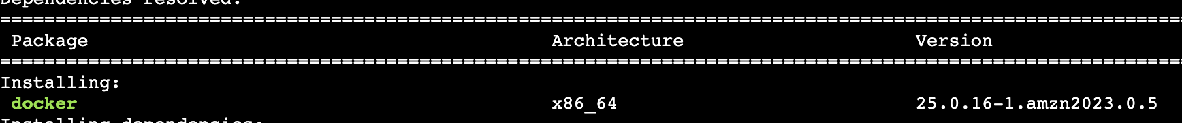

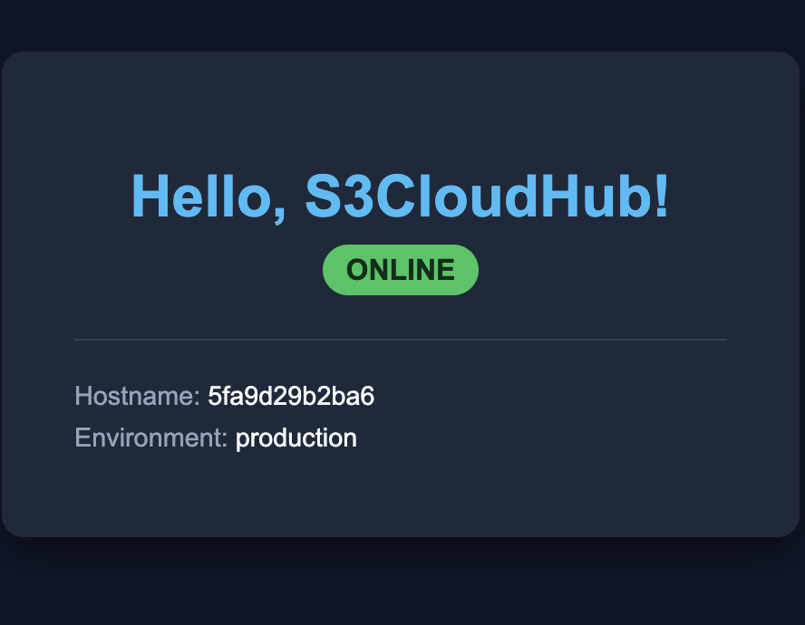

2)Step 1: Confirm Docker Hub Authentication
Ensure your Docker CLI session is authenticated with your Docker Hub account:

Bash
docker login -u sreedocker95

When prompted, enter your Docker Hub password or Personal Access Token.

- Verification: The terminal will display Login Succeeded.

Step 2: Identify and Tag the Local Image
Check your local images to confirm the repository name and tag:
Bash
docker images

If the image was built locally without your Docker Hub username prefix (for example, just frontend-app:v1), tag it so Docker routes it to your registry:

Bash
docker tag frontend-app:v1 sreedocker95/frontend-app:v1

- Verification: Run docker images | grep sreedocker95 to confirm the tagged image appears in the list.

Step 3: Push the Image
Upload the image layers to Docker Hub:
Bash
docker push sreedocker95/frontend-app:v1

(If you are pushing a different service, substitute the image name and tag, e.g., sreedocker95/java-app:v1 or sreedocker95/nodejs-app:v1.)

- Verification: The terminal will display upload progress bars for each layer and terminate with
- Plaintext
v1: digest: sha256:... size: ...

Step 4: Verify in Docker Hub
- Open your browser and navigate to hub.docker.com.
- Go to your Repositories list.
- Select your repository (e.g., frontend-app) and check the Tags tab to confirm tag v1 is listed with a recent timestamp
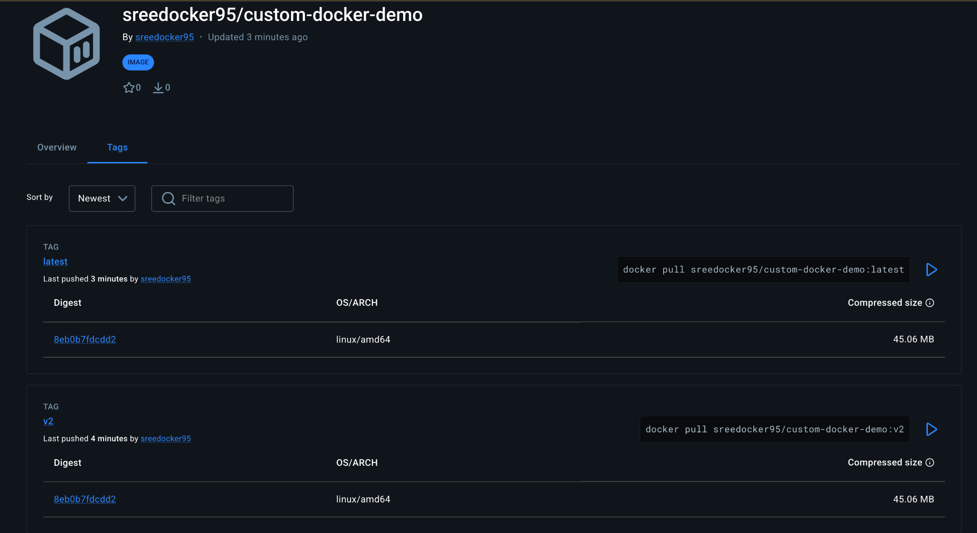

3)Pushing Container Images to Amazon Elastic Container Registry (ECR)

1. Objective
Create a private Amazon ECR repository in region ap-southeast-2, authenticate the local Docker daemon against the AWS ECR registry using the AWS CLI, tag the existing local image (sreedocker95/frontend-app:v1), and push it to AWS ECR.

2. Architecture & Environment Details
- Cloud Provider: AWS
- Service: Amazon Elastic Container Registry (ECR)
- AWS Region: ap-southeast-2 (Sydney)
- ECR Registry URI Format: <AWS_ACCOUNT_ID>.dkr.ecr.ap-southeast-2.amazonaws.com
- ECR Repository Name: frontend-app
- Local Source Image: sreedocker95/frontend-app:v1
- Target Image Tag: <AWS_ACCOUNT_ID>[.dkr.ecr.ap-southeast-2.amazonaws.com/frontend-app:v1](https://.dkr.ecr.ap-southeast-2.amazonaws.com/frontend-app:v1)
- Required IAM Policy: AmazonEC2ContainerRegistryPowerUser or AmazonEC2ContainerRegistryFullAccess attached to your instance role or AWS CLI profile.

3. Step-by-Step Execution

Step 1: Retrieve Your AWS Account ID & Set Variables
Export your target AWS Region and dynamic Account ID into your shell session:

Bash
export AWS_REGION="ap-southeast-2"
export AWS_ACCOUNT_ID=$(aws sts get-caller-identity --query Account --output text)
export ECR_REPO_NAME="frontend-app"
export IMAGE_TAG="v1"

- Command breakdown:
  - aws sts get-caller-identity: Queries the active AWS IAM role/credentials to fetch your 12-digit AWS Account ID dynamically.
- Verification:
- Bash
echo "Account ID: $AWS_ACCOUNT_ID | Region: $AWS_REGION"

- Ensure a 12-digit number prints without errors.

Step 2: Create the Private ECR Repository
Create the target repository in Amazon ECR to host the image:
Bash
aws ecr create-repository \
--repository-name ${ECR_REPO_NAME} \
--region ${AWS_REGION} \
--image-scanning-configuration scanOnPush=true \
--image-tag-mutability MUTABLE

- Command breakdown:
  - create-repository: Provisions the registry namespace on AWS.
  - --image-scanning-configuration scanOnPush=true: Automatically triggers a security scan on every image push.
  - --image-tag-mutability MUTABLE: Allows tags to be overwritten if re-released.
- Verification:
- Bash
aws ecr describe-repositories --repository-names ${ECR_REPO_NAME} --region ${AWS_REGION}

- The JSON output will display the repository's metadata and the repositoryUri.

Step 3: Authenticate Docker to Your ECR Registry
Generate an authentication token using AWS CLI and pipe it directly to Docker CLI login:

Bash
aws ecr get-login-password --region ${AWS_REGION} | docker login --username AWS --password-stdin ${AWS_ACCOUNT_ID}.dkr.ecr.${AWS_REGION}.amazonaws.com

- Command breakdown:
  - aws ecr get-login-password: Generates a short-lived (12-hour) base64 authentication string.
  - docker login --username AWS --password-stdin: Passes the temporary token directly into Docker without writing secrets to your command history.
- Verification: The terminal must output:
- Plaintext
Login Succeeded

Step 4: Tag the Local Docker Image for ECR
Docker requires images to be tagged with the exact repository URI of the remote registry:
Bash
docker tag sreedocker95/frontend-app:v1 ${AWS_ACCOUNT_ID}.dkr.ecr.${AWS_REGION}.amazonaws.com/${ECR_REPO_NAME}:${IMAGE_TAG}

- Command breakdown:
  - docker tag: Creates an alias of the existing local image pointing to the Amazon ECR endpoint structure.
- Verification:
- Bash
docker images | grep ${ECR_REPO_NAME}

- You should see an image matching <AWS_ACCOUNT_ID>[.dkr.ecr.ap-southeast-2.amazonaws.com/frontend-app](https://.dkr.ecr.ap-southeast-2.amazonaws.com/frontend-app) with tag v1.

Step 5: Push the Image to Amazon ECR
Upload the image layers to your private repository:

Bash
docker push ${AWS_ACCOUNT_ID}.dkr.ecr.${AWS_REGION}.amazonaws.com/${ECR_REPO_NAME}:${IMAGE_TAG}

- Command breakdown:
  - docker push: Transmits the image layers to your authenticated private registry in ap-southeast-2.
- Verification:
- Look for the layer upload progress bars and final completion digest:
- Plaintext
v1: digest: sha256:... size: 1572

4. Verification in AWS ECR
Verify the pushed image details directly using the AWS CLI:
Bash
aws ecr describe-images \
--repository-name ${ECR_REPO_NAME} \
--region ${AWS_REGION} \
--query 'imageDetails[*].[imageTags, imagePushedAt, imageSizeInBytes]' \
--output table

- Expected Output: A table confirming tag v1 exists with its push timestamp and size in bytes.

5. Tear-Down (Optional Lab Cleanup)
To remove the ECR repository and its stored images after finishing the task:
Bash
aws ecr delete-repository \
--repository-name ${ECR_REPO_NAME} \
--region ${AWS_REGION} \
--force

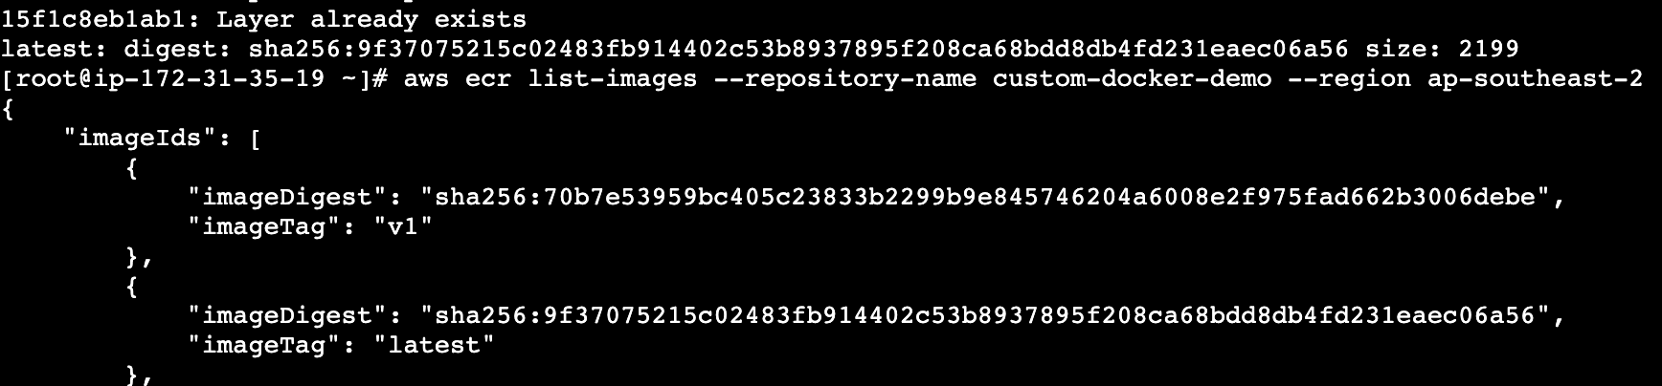

4)Provision one EC2 instance using Terraform and install Jenkins.
1. Objective
Provision a dedicated AWS EC2 instance in the ap-southeast-2 (Sydney) region using Terraform and deploy an operational Jenkins Continuous Integration server accessible via port 8080.

2. Architecture & Specifications
Component | Specification
Cloud Provider | AWS (ap-southeast-2 / Sydney)
Instance Type | m7i-flex.large (Eligible under account policy)
Root Volume | 30 GB EBS (gp3)
Base OS | Amazon Linux 2023 (x86_64)
Security Ingress | TCP 22 (SSH), TCP 8080 (Jenkins UI)
Security Egress | All Outbound (-1 / 0.0.0.0/0)
Runtime Dependencies | Amazon Corretto 21 (Java 21 required by modern Jenkins core)
Application | Jenkins LTS

3. Terraform Configuration (main.tf)
Directory: ~/jenkins-terraform/main.tf
Terraform
terraform {
required_version = ">= 1.5.0"
required_providers {
aws = {
source = "hashicorp/aws"
version = "~> 5.0"
}
}
}

provider "aws" {
region = "ap-southeast-2"
}

# 1. Fetch latest Amazon Linux 2023 AMI
data "aws_ami" "amazon_linux_2023" {
most_recent = true
owners = ["amazon"]

filter {
name = "name"
values = ["al2023-ami-2023.*-x86_64"]
}

filter {
name = "virtualization-type"
values = ["hvm"]
}
}

# 2. Security Group Configuration
resource "aws_security_group" "jenkins_sg" {
name = "jenkins-server-sg"
description = "Allow Jenkins and SSH inbound traffic"

ingress {
description = "SSH"
from_port = 22
to_port = 22
protocol = "tcp"
cidr_blocks = ["0.0.0.0/0"]
}

ingress {
description = "Jenkins Web Interface"
from_port = 8080
to_port = 8080
protocol = "tcp"
cidr_blocks = ["0.0.0.0/0"]
}

egress {
from_port = 0
to_port = 0
protocol = "-1"
cidr_blocks = ["0.0.0.0/0"]
}

tags = {
Name = "Jenkins-Security-Group"
}
}

# 3. EC2 Instance Provisioning
resource "aws_instance" "jenkins" {
ami = data.aws_ami.amazon_linux_2023.id
instance_type = "m7i-flex.large"
vpc_security_group_ids = [aws_security_group.jenkins_sg.id]

root_block_device {
volume_size = 30
volume_type = "gp3"
delete_on_termination = true
}

user_data = <<-EOF
#!/bin/bash
dnf update -y
dnf install -y java-21-amazon-corretto-devel git wget
wget -O /etc/yum.repos.d/jenkins.repo https://pkg.jenkins.io/redhat-stable/jenkins.repo
rpm --import https://pkg.jenkins.io/redhat-stable/jenkins.io-2023.key
dnf upgrade -y
dnf install -y jenkins
systemctl daemon-reload
systemctl enable --now jenkins
EOF

tags = {
Name = "Jenkins-Terraform-Instance"
}
}

# 4. Outputs
output "jenkins_web_url" {
value = "http://${aws_instance.jenkins.public_ip}:8080"
}

4. Step-by-Step Execution Record

Phase 1: Environment Setup
- Installed Terraform on the primary management EC2 instance using the official HashiCorp RPM repository.
- Created the project directory:
- Bash:
mkdir -p ~/jenkins-terraform && cd ~/jenkins-terraform
- Initialized working directory:
- Bash
terraform init

Phase 2: Resolving Policy & Quota Constraints
- IAM Permissions: Initial AMI lookup failed with 403 UnauthorizedOperation: ec2:DescribeImages. Resolved by attaching the AmazonEC2FullAccess policy to the instance role (EC2-Jenkins-ECR-Role).
- Free Tier / Allowed Instance Type Filtering: Attempts with t3.medium and t2.micro failed due to account constraints (InvalidParameterCombination: The specified instance type is not eligible for Free Tier).
- Queried allowed instance types:
- Bash
aws ec2 describe-instance-types \
--region ap-southeast-2 \
--filters "Name=free-tier-eligible,Values=true" \
--query "InstanceTypes[*].InstanceType" --output table
- Selected the supported compute-optimized size: m7i-flex.large with 30 GB EBS.

Phase 3: Resource Provisioning
Applied infrastructure definition:
Bash
terraform apply -auto-approve

- Instance ID: i-0eedee96e6206acc5
- Public IPv4: 13.239.250.225
- Target Endpoint: [http://13.239.250.225:8080](http://13.239.250.225:8080)

Phase 4: Service Resolution & Java Upgrade
- Inspection of service status on ip-172-31-38-225 (i-0eedee96e6206acc5) showed systemd startup failure:
- Plaintext
Running with Java 17 from /usr/lib/jvm/java-17-amazon-corretto.x86_64, which is older than the minimum required version (Java 21).
Supported Java versions are:
- Connected to instance i-0eedee96e6206acc5 via EC2 Instance Connect and installed Amazon Corretto 21:
- Bash
sudo dnf install -y java-21-amazon-corretto-devel
sudo systemctl reset-failed jenkins.service
sudo systemctl restart jenkins
- Verified status:
- Bash
sudo systemctl status jenkins
# Active: active (running)

Phase 5: Jenkins Server Initialization
- Retrieved the generated master setup key:
- Bash
sudo cat /var/lib/jenkins/secrets/initialAdminPassword
- Navigated to [http://13.239.250.225:8080](http://13.239.250.225:8080) in the browser.
- Unlocked Jenkins using the retrieved secret token and proceeded with initial plugin setup.

5. Tear-down & Resource Decommissioning
To remove all provisioned infrastructure and avoid billing after the lab session:
Bash
cd ~/jenkins-terraform
terraform destroy -auto-approve
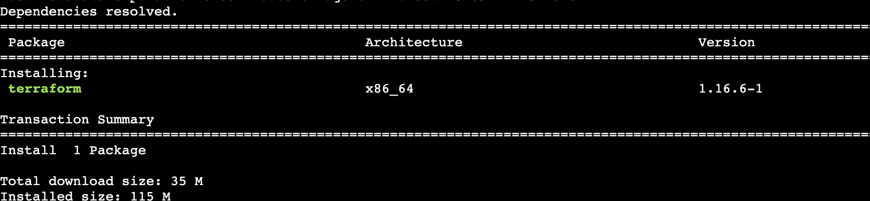
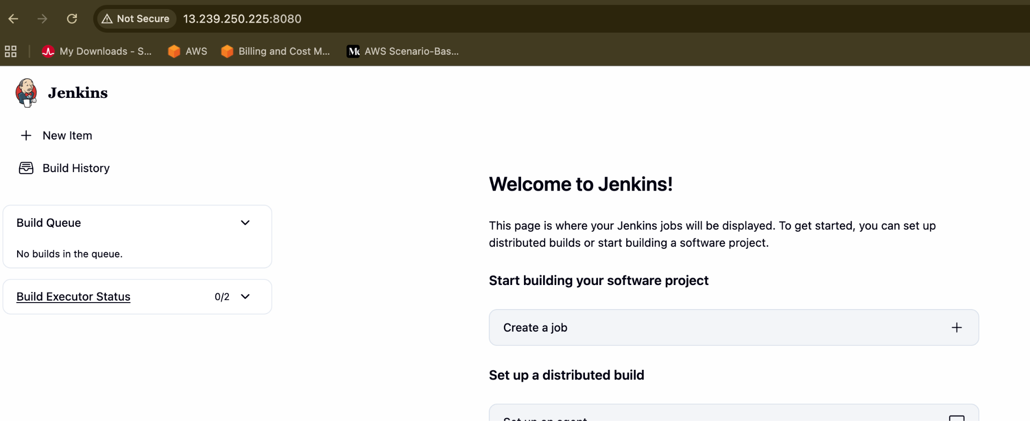

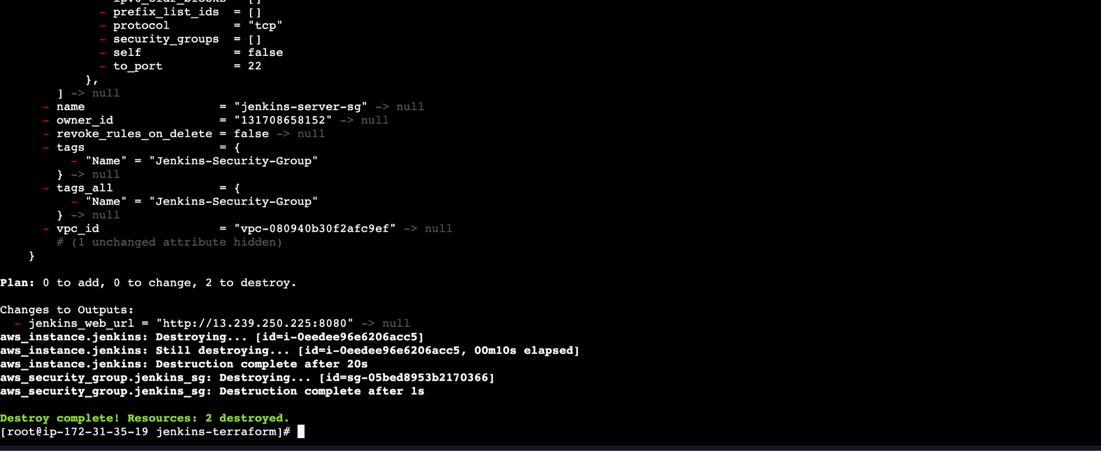

5)Create a Jenkins pipeline to create a docker image and push the image to Docker hub.

In order to complete this task, we need Java along with Jenkins installed in our EC2 instance. And then we have to get login here with the help of the predefined password which is been allocated the time when we are installing the Jenkins. We have to paste the password here in order to login and we have to install the Jenkins in build plugins to run the pipeline
What is a Jenkins Pipeline? (Beginner Overview)
- Jenkins Pipeline is a suite of plugins that allows you to define your entire build, test, and deployment workflow using code inside a Jenkinsfile.
- The Goal: Instead of running manual terminal commands, we automate the process so Jenkins handles building the container, authenticating with Docker Hub using securely stored credentials, and publishing the image automatically.

The Objective
Write and execute a Declarative Jenkins Pipeline on an AWS EC2 instance (running Java 21 and Docker) to build a custom Docker image from a Dockerfile workspace and push it directly to Docker Hub.

Prerequisites & Environment Details
- Active Environment: AWS EC2 instance running Jenkins (v2.580.1) configured with Java 21 (java-21-amazon-corretto) and Docker.
- Jenkins Workspace: /var/lib/jenkins/workspace/Docker (where Jenkins looks for project source files).
- Credentials Required: A saved global credential ID in Jenkins named dockerhub-credentials (Username with password).
- Target Image Tag: sreedocker95/my-alpine-tomcat:v1

Pin-to-Pin Steps & Command Breakdown

Step 1: Add Docker Hub Credentials to Jenkins
- Log into your Jenkins Dashboard (http://<YOUR-EC2-IP>:8080).
- Go to Manage Jenkins > Credentials > System > Global credentials (unrestricted).
- Click Add Credentials and configure:
  - Kind: Username with password
  - Username: Your Docker Hub username (sreedocker95)
  - Password: Your Docker Hub password or Personal Access Token
  - ID: dockerhub-credentials (Must match this exact ID)
- Click Create.

Step 2: Prepare the Workspace Directory for Jenkins
Because Jenkins looks inside its specific workspace directory for project files, ensure your Dockerfile is copied into the job's workspace:
sudo mkdir -p /var/lib/jenkins/workspace/Docker
sudo cp /root/tomcat-folder/Dockerfile /var/lib/jenkins/workspace/Docker/
sudo chown -R jenkins:jenkins /var/lib/jenkins/workspace/Docker/

- Command Breakdown:
  - sudo cp: Copies your source Dockerfile from its local creation path into the active Jenkins job workspace directory.
  - sudo chown: Grants ownership of the workspace files to the jenkins system user so the Jenkins daemon has permission to read them during builds.

Step 3: Create and Configure the Jenkins Pipeline Job
- Go back to the Jenkins Home page and click New Item.
- Name your job (e.g., Docker), select Pipeline, and click OK.
- Scroll down to the Pipeline section, set Definition to Pipeline script, and paste the following declarative script:
pipeline {
agent any

environment {
DOCKERHUB_CREDENTIALS = credentials('dockerhub-credentials')
IMAGE_NAME = 'sreedocker95/my-alpine-tomcat'
IMAGE_TAG = 'v1'
}

stages {
stage('Verify Directory & Dockerfile') {
steps {
echo 'Checking workspace files...'
sh 'pwd && ls -la'
}
}

stage('Build Docker Image') {
steps {
echo 'Building the Docker image...'
sh "docker build -t $IMAGE_{N}AME:${IMAGE_TAG} ."
}
}

stage('Login to Docker Hub') {
steps {
echo 'Logging into Docker Hub...'
sh 'echo "$DOCKERHUB_{C}REDENTIALS_{P}SW"|dockerlogin-u"$DOCKERHUB_CREDENTIALS_USR" --password-stdin'
}
}

stage('Push Docker Image') {
steps {
echo 'Pushing image to Docker Hub...'
sh "docker push $IMAGE_{N}AME:${IMAGE_TAG}"
}
}
}

post {
success {
echo 'Pipeline completed successfully! Image pushed to Docker Hub.'
}
failure {
echo 'Pipeline failed. Check console logs.'
}
}
}

- Pipeline Script Breakdown:
  - Verify Directory & Dockerfile: Prints the current directory and checks that the Dockerfile is present in the workspace.
  - Build Docker Image: Executes standard docker build using the local workspace context (.).
  - Login to Docker Hub: Securely unwraps the Jenkins credential block using _USR and _PSW suffixes to authenticate via docker login without exposing secrets in logs.
  - Push Docker Image: Uploads the built layers to your Docker Hub repository.

Step 4: Run and Verify the Pipeline
- Click Save, then click Build Now on the left menu.
- Click the active build number under Build History, then click Console Output to monitor the execution.
- Confirm that the final status displays Finished: SUCCESS.
- Log into Docker Hub to verify that your repository and tag (sreedocker95/my-alpine-tomcat:v1) are successfully published.

Conclusion for Task 8
By setting up a version-controlled Jenkins Pipeline integrated with proper workspace file management and secure credential handling, we achieved a fully automated CI/CD loop that builds container images and pushes them directly to Docker Hub.
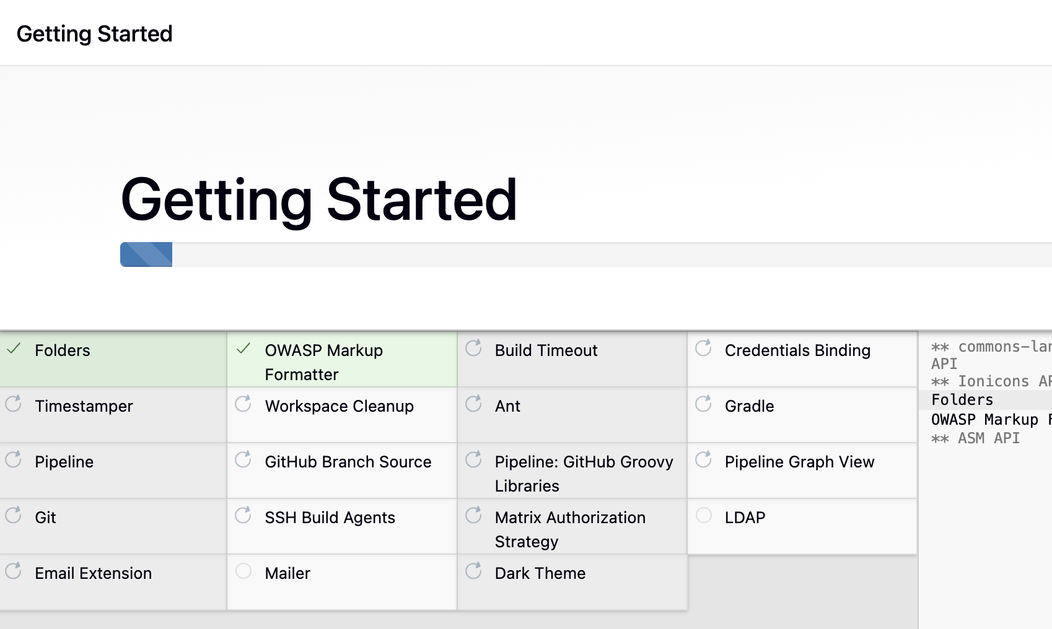

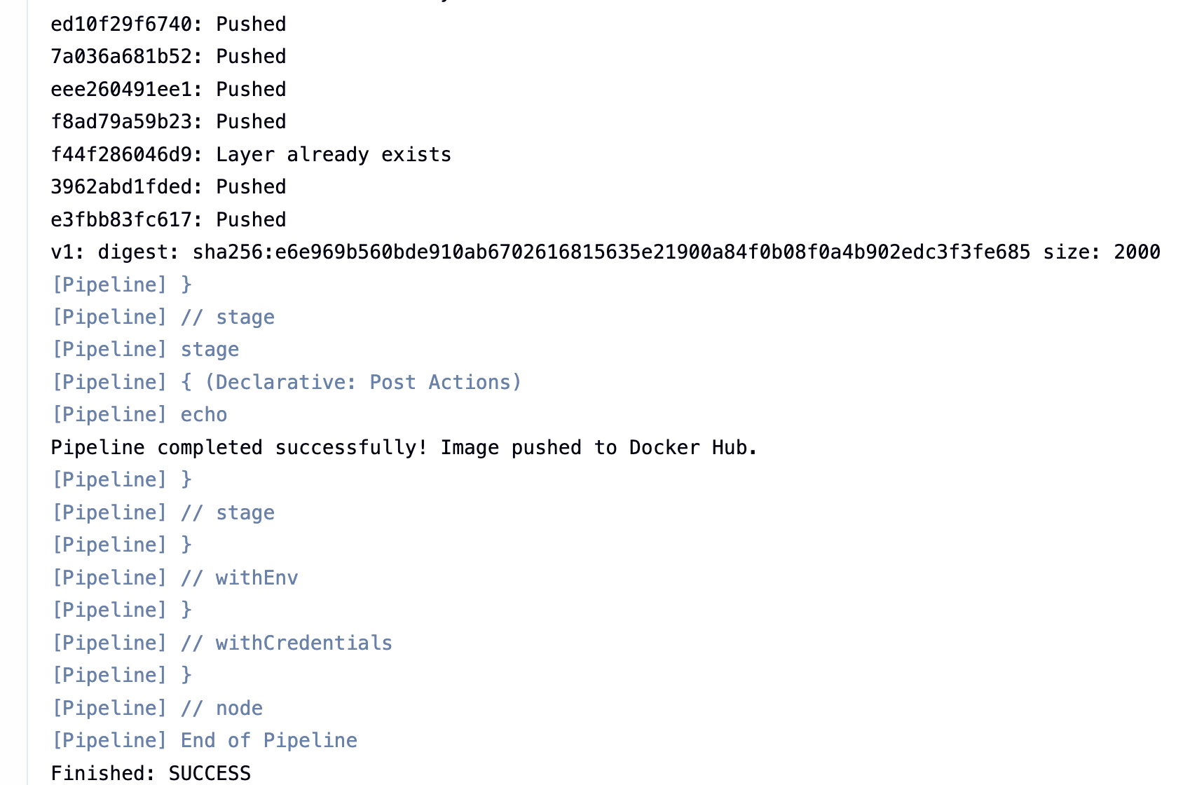

6)
- The repository folder on your machine is plural: docker-tasks (you typed singular docker-task).
- Inside that repository, the folder is named Frontend_based_source (matching your GitHub screenshot), not frontend.

Step 1: Navigate to the Frontend Source Folder
Run this exact path command:
Bash
cd ~/docker-tasks/Frontend_based_source

- Command breakdown:
  - cd: Change directory.
  - ~/docker-tasks/Frontend_based_source: Goes into the docker-tasks directory, then into the exact Frontend_based_source folder.
- How to verify: Run pwd && ls -la.
  - Expected output: Your working directory shows /root/docker-tasks/Frontend_based_source, and you will see index.html, javascript.js, style.css, and todayDeal.js.

Step 2: Create the Dockerfile
Because this project consists of static frontend web files (index.html, CSS, JavaScript), package them with a lightweight Nginx web server:
Bash
cat << 'EOF' > Dockerfile
FROM nginx:alpine
COPY . /usr/share/nginx/html
EXPOSE 80
CMD ["nginx", "-g", "daemon off;"]
EOF

- Command breakdown:
  - cat << 'EOF' > Dockerfile ... EOF: Writes the configuration block into a new file named Dockerfile.
  - FROM nginx:alpine: Uses an Alpine Linux image pre-configured with Nginx (~15 MB).
  - COPY . /usr/share/nginx/html: Copies your HTML, CSS, and JS files into Nginx's default root serving folder.
  - EXPOSE 80: Informs Docker that Nginx listens for inbound HTTP traffic on port 80.
  - CMD ["nginx", "-g", "daemon off;"]: Runs Nginx in the foreground so the container does not terminate.
- How to verify: Run cat Dockerfile — it should output those exact 4 lines.

Step 3: Build the Docker Image
Bash
docker build -t sreedocker95/frontend-app:v1 .

- Command breakdown:
  - docker build: Assembles the Docker image according to the Dockerfile.
  - -t sreedocker95/frontend-app:v1: Tags the image with your Docker Hub account name, repository name, and version v1.
  - .: Specifies the current directory (Frontend_based_source) as the build context.
- How to verify: Run docker images | grep frontend-app.
  - Expected output: A row displaying sreedocker95/frontend-app with tag v1.

Step 4: Run the Docker Container
Bash
docker run -d --name frontend-app-container -p 80:80 sreedocker95/frontend-app:v1

- Command breakdown:
  - docker run: Creates and launches the container.
  - -d: Runs detached in the background.
  - --name frontend-app-container: Sets a distinct container name.
  - -p 80:80: Forwards port 80 on your EC2 host to port 80 inside the container.
- How to verify: Run docker ps.
  - Expected output: frontend-app-container is listed with status Up. Run curl -I http://localhost:80 to confirm an HTTP/1.1 200 OK response.

Step 5: Push the Image to Docker Hub
Bash
docker push sreedocker95/frontend-app:v1

- Command breakdown:
  - docker push: Uploads your newly built image directly to your Docker Hub repository.
- How to verify: The terminal will display progress bars and finish with v1: digest: sha256:.... Open hub.docker.com in your browser to verify sreedocker95/frontend-app is visible with the v1 tag.
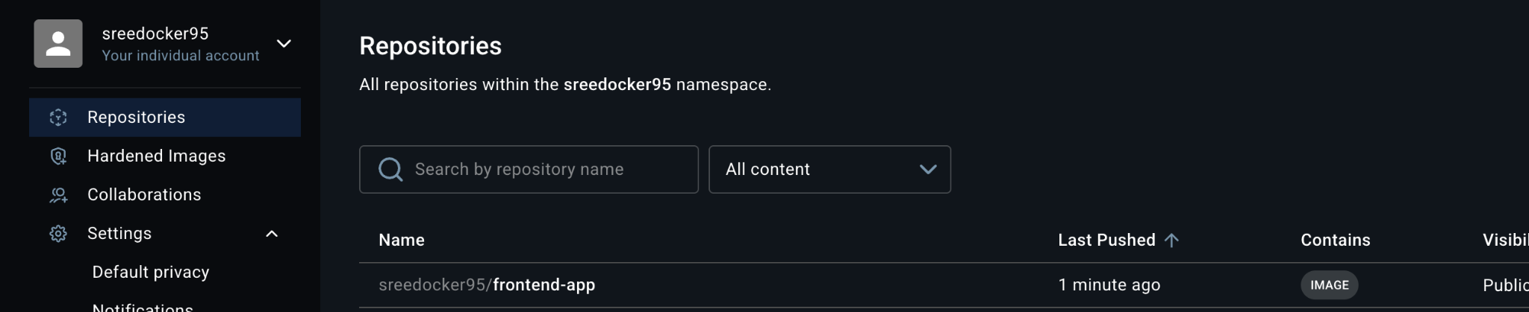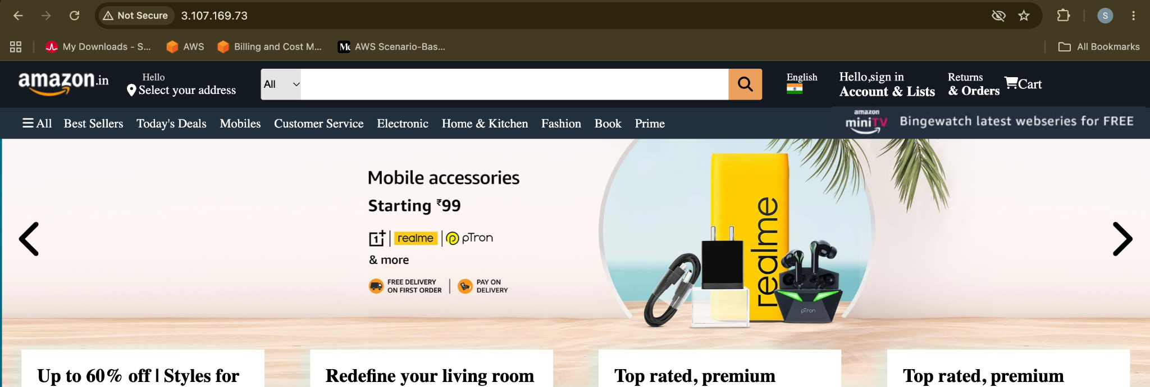

7)Task 2: Containerizing the Java Application (Maven & Corretto 21)

1. Objective
Implement a multi-stage Docker build to compile a Java application using Maven and deploy it inside a minimal Amazon Corretto 21 runtime.

2. Architecture & Environment
- Source Path: ~/docker-tasks/Java_based_source
- Build Stage: maven:3.9.6-amazoncorretto-21
- Runtime Stage: amazoncorretto:21-alpine
- Host Port: 8081 | Container Port: 8080
- Target Image: sreedocker95/java-app:v1

3. Dockerfile
File location: ~/docker-tasks/Java_based_source/Dockerfile
Dockerfile
# Stage 1: Compile and package
FROM maven:3.9.6-amazoncorretto-21 AS builder
WORKDIR /app
COPY pom.xml .
RUN mvn dependency:go-offline -B || true
COPY src ./src
RUN mvn clean package -DskipTests

# Stage 2: Minimal runtime image
FROM amazoncorretto:21-alpine
WORKDIR /app
COPY --from=builder /app/target/*.jar app.jar
EXPOSE 8080
ENTRYPOINT ["java", "-jar", "app.jar"]

4. Step-by-Step Execution
- Navigate to directory:
- Bash
cd ~/docker-tasks/Java_based_source
- Build the image:
- Bash
docker build -t sreedocker95/java-app:v1 .
- Run the container on port 8081:
- Bash
docker run -d --name java-app-container -p 8081:8080 sreedocker95/java-app:v1
- Publish to Docker Hub:
- Bash
docker push sreedocker95/java-app:v1

5. Verification
- Check runtime logs:
- Bash
docker logs java-app-container
- Verify service response:
- Bash
- curl -I http://localhost:8081

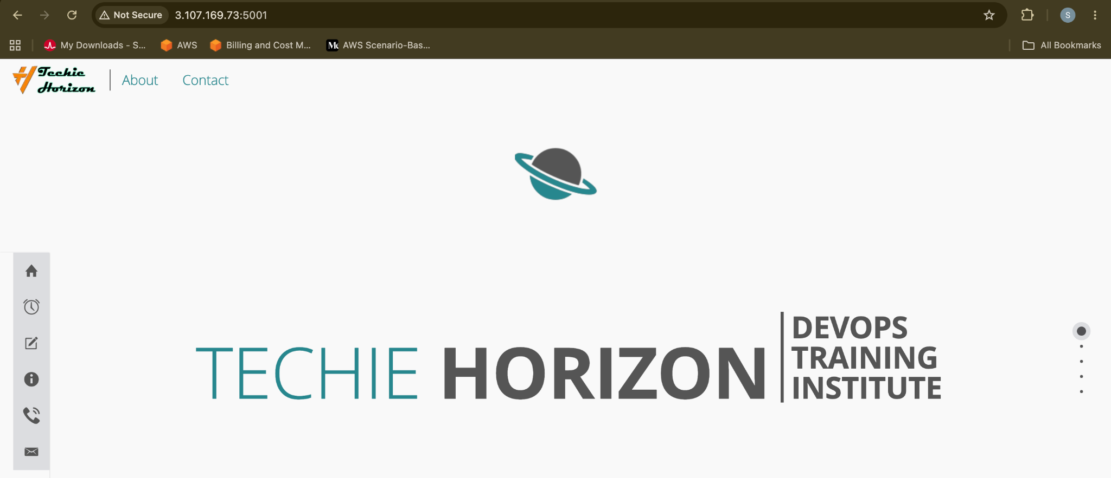

8)Task 3: Containerizing the Node.js Application

1. Objective
Containerize a Node.js web service using Alpine Linux, expose port 3000, build with tag v1, and publish to Docker Hub.

2. Architecture & Environment
- Source Path: ~/docker-tasks/NodeJs_based_source
- Base Image: node:18-alpine
- Host Port: 3000 | Container Port: 3000
- Target Image: sreedocker95/nodejs-app:v1

3. Dockerfile
File location: ~/docker-tasks/NodeJs_based_source/Dockerfile
Dockerfile
FROM node:18-alpine

WORKDIR /usr/src/app

COPY package*.json ./
RUN npm install

COPY . .

EXPOSE 3000
CMD ["npm", "start"]

4. Step-by-Step Execution
- Navigate to directory:
- Bash
cd ~/docker-tasks/NodeJs_based_source
- Build the image with explicit v1 tag:
- Bash
docker build -t sreedocker95/nodejs-app:v1 .
- Run the container:
- Bash
docker run -d --name nodejs-app-container -p 3000:3000 sreedocker95/nodejs-app:v1
- Push the image:
- Bash
docker push sreedocker95/nodejs-app:v1

5. Verification
- Process Status: Check docker ps for container name nodejs-app-container.
- Local connectivity:
- Bash
curl -I http://localhost:3000

Task 4: Infrastructure Provisioning with Terraform & Jenkins Setup

1. Objective
Provision an AWS EC2 instance using Terraform in ap-southeast-2, configure security groups, install Java 21, and deploy an operational Jenkins LTS server.

2. Infrastructure Specifications
- Cloud Provider: AWS (ap-southeast-2)
- Instance Type: m7i-flex.large (30 GB gp3 root volume)
- Ports Configured: Inbound 22 (SSH), 8080 (Jenkins)
- Required Dependency: Amazon Corretto 21 (java-21-amazon-corretto-devel)

3. Terraform Configuration (main.tf)
File location: ~/jenkins-terraform/main.tf
Terraform
terraform {
required_version = ">= 1.5.0"
required_providers {
aws = {
source = "hashicorp/aws"
version = "~> 5.0"
}
}
}

provider "aws" {
region = "ap-southeast-2"
}

data "aws_ami" "amazon_linux_2023" {
most_recent = true
owners = ["amazon"]
filter {
name = "name"
values = ["al2023-ami-2023.*-x86_64"]
}
}

resource "aws_security_group" "jenkins_sg" {
name = "jenkins-server-sg"
description = "Allow Jenkins and SSH inbound traffic"

ingress {
from_port = 22
to_port = 22
protocol = "tcp"
cidr_blocks = ["0.0.0.0/0"]
}

ingress {
from_port = 8080
to_port = 8080
protocol = "tcp"
cidr_blocks = ["0.0.0.0/0"]
}

egress {
from_port = 0
to_port = 0
protocol = "-1"
cidr_blocks = ["0.0.0.0/0"]
}
}

resource "aws_instance" "jenkins" {
ami = data.aws_ami.amazon_linux_2023.id
instance_type = "m7i-flex.large"
vpc_security_group_ids = [aws_security_group.jenkins_sg.id]

root_block_device {
volume_size = 30
volume_type = "gp3"
}

user_data = <<-EOF
#!/bin/bash
dnf update -y
dnf install -y java-21-amazon-corretto-devel git wget
wget -O /etc/yum.repos.d/jenkins.repo https://pkg.jenkins.io/redhat-stable/jenkins.repo
rpm --import https://pkg.jenkins.io/redhat-stable/jenkins.io-2023.key
dnf upgrade -y
dnf install -y jenkins
systemctl daemon-reload
systemctl enable --now jenkins
EOF
}

output "jenkins_url" {
value = "http://${aws_instance.jenkins.public_ip}:8080"
}

4. Step-by-Step Execution
- Initialize and apply Terraform:
- Bash
cd ~/jenkins-terraform
terraform init
terraform apply -auto-approve

- Resolve Java runtime requirements on target EC2:
- Bash
sudo dnf install -y java-21-amazon-corretto-devel
sudo systemctl reset-failed jenkins.service
sudo systemctl restart jenkins

- Retrieve initial admin credentials:
- Bash
sudo cat /var/lib/jenkins/secrets/initialAdminPassword

- Access http://<INSTANCE-PUBLIC-IP>:8080 to complete the initial setup wizard.

Task 5: Jenkins Pipeline for Automated Image Build & Docker Hub Push

1. Objective
Configure a Declarative Jenkins Pipeline job (Docker) that reads a Dockerfile from the workspace, builds the image, authenticates with Docker Hub via Jenkins Global Credentials, and pushes the image.

2. Environment & Prerequisites
- Jenkins Job Name: Docker
- Workspace Path: /var/lib/jenkins/workspace/Docker/
- Jenkins Credential ID: dockerhub-credentials (Username with password)
- Target Image: sreedocker95/my-alpine-tomcat:v1

3. Pipeline Configuration (Jenkinsfile)
Groovy
pipeline {
agent any

environment {
DOCKERHUB_CREDENTIALS = credentials('dockerhub-credentials')
IMAGE_NAME = 'sreedocker95/my-alpine-tomcat'
IMAGE_TAG = 'v1'
}

stages {
stage('Verify Directory & Dockerfile') {
steps {
echo 'Checking workspace files...'
sh 'pwd && ls -la'
}
}

stage('Build Docker Image') {
steps {
echo 'Building the Docker image...'
sh "docker build -t $IMAGE_{N}AME:${IMAGE_TAG} ."
}
}

stage('Login to Docker Hub') {
steps {
echo 'Logging into Docker Hub...'
sh 'echo "$DOCKERHUB_{C}REDENTIALS_{P}SW"|dockerlogin-u"$DOCKERHUB_CREDENTIALS_USR" --password-stdin'
}
}

stage('Push Docker Image') {
steps {
echo 'Pushing image to Docker Hub...'
sh "docker push $IMAGE_{N}AME:${IMAGE_TAG}"
}
}
}

post {
success {
echo 'Pipeline completed successfully! Image pushed to Docker Hub.'
}
failure {
echo 'Pipeline failed. Check console logs.'
}
always {
sh 'docker logout || true'
}
}
}

4. Step-by-Step Execution
- Prepare the workspace:
- Bash
sudo mkdir -p /var/lib/jenkins/workspace/Docker
sudo cp /root/tomcat-folder/Dockerfile /var/lib/jenkins/workspace/Docker/
sudo chown -R jenkins:jenkins /var/lib/jenkins/workspace/Docker/
- Grant Docker daemon access to Jenkins user:
- Bash
sudo usermod -aG docker jenkins
sudo systemctl restart jenkins
- Create the Jenkins Job:
  - Create a new Pipeline job named Docker.
  - Under Pipeline Script, paste the Groovy pipeline code above.
  - Save and click Build Now.

5. Verification
- Console output terminates with:
- Plaintext
Pushing image to Docker Hub...
v1: digest: sha256:...
Finished: SUCCESS


9)Task 6: Deploying WordPress and MySQL with Docker Compose

1. Objective
Deploy a multi-tier WordPress and MySQL 8.0 architecture with persisted EBS storage volumes and isolated bridge networking.

2. Architecture & Port Mapping
- Directory: ~/wordpress-compose
- Services: db (MySQL 8.0) and wordpress (WordPress latest)
- Host Port: 8082 | Container Port: 80
- Volumes: db_data (MySQL files), wp_data (WordPress assets)
- Network: wp_network (bridge)

3. Docker Compose Specification (docker-compose.yml)
File location: ~/wordpress-compose/docker-compose.yml
YAML
services:
db:
image: mysql:8.0
container_name: wordpress_db
restart: always
environment:
MYSQL_ROOT_PASSWORD: rootpassword123
MYSQL_DATABASE: wordpress
MYSQL_USER: wp_user
MYSQL_PASSWORD: wp_user_password123
volumes:
- db_data:/var/lib/mysql
networks:
- wp_network

wordpress:
image: wordpress:latest
container_name: wordpress_app
restart: always
depends_on:
- db
ports:
- "8082:80"
environment:
WORDPRESS_DB_HOST: db:3306
WORDPRESS_DB_NAME: wordpress
WORDPRESS_DB_USER: wp_user
WORDPRESS_DB_PASSWORD: wp_user_password123
volumes:
- wp_data:/var/www/html
networks:
- wp_network

volumes:
db_data:
wp_data:

networks:
wp_network:
driver: bridge

4. Step-by-Step Execution
- Create directory and deploy stack:
- Bash
mkdir -p ~/wordpress-compose && cd ~/wordpress-compose
docker compose up -d
- Open Inbound Port 8082:
  - In AWS EC2 Console, navigate to the security group of instance i-0ef3a15b68074b4bf.
  - Add Inbound Rule: Custom TCP, Port 8082, Source 0.0.0.0/0.

5. Verification
- Check status:
- Bash
docker compose ps
- Verify HTTP redirection:
- Bash
curl -I http://localhost:8082
- Expected Output:
- Plaintext
HTTP/1.1 302 Found
Location: http://...:8082/wp-admin/install.php

- Browser Access: Navigate to http://<PUBLIC-IP>:8082 to run the WordPress web installation.

### 1. Navigate to the Node.js Source Directory

Move into the Node.js directory inside `docker-tasks`:

```bash
cd ~/docker-tasks/NodeJs_based_source

```

* **Command breakdown:**
* `cd`: Changes directory to the target folder.
* `~/docker-tasks/NodeJs_based_source`: The exact path containing the Node.js application files (`package.json`, application entry file, etc.).

* **Verification:** Run `ls -la`. You should see `package.json` and the source files.

---

### 2. Create the `Dockerfile`

Create an optimized Dockerfile using an official Node.js Alpine base image:
bash
cat << 'EOF' > Dockerfile
FROM node:18-alpine
WORKDIR /usr/src/app
COPY package*.json ./
RUN npm install
COPY . .
EXPOSE 3000
CMD ["npm", "start"]
EOF

* Command & Dockerfile breakdown:
* `FROM node:18-alpine`: Lightweight base image containing Node.js 18 and npm on Alpine Linux (~50 MB).
* `WORKDIR /usr/src/app`: Creates and sets the active working directory inside the container.
* `COPY package*.json ./`: Copies `package.json` and `package-lock.json` first to leverage Docker layer caching.
* `RUN npm install`: Installs the required application dependencies.
* `COPY . .`: Copies the remaining application source files into the container.
* `EXPOSE 3000`: Informs Docker that the Node.js service listens on port 3000.
* `CMD ["npm", "start"]`: The command to start the application (fallback if needed: `["node", "server.js"]` or `["node", "index.js"]` depending on the script defined in `package.json`).

* Verification:** Run `cat Dockerfile` to confirm the contents.

3. Build the Image with Tag `v1`

Build the image tagged under your Docker Hub repository:

bash
docker build -t sreedocker95/nodejs-app:v1 .

* **Command breakdown:**
* `docker build`: Compiles the container image from the `Dockerfile`.
* `-t sreedocker95/nodejs-app:v1`: Sets the image repository name and explicitly assigns the required `v1` tag.
* Uses the current directory as the build context.

* Verification: Run `docker images | grep nodejs-app`. You should see `sreedocker95/nodejs-app` with tag `v1`.

---

4. Run the Container

Run the newly built container in detached mode, exposing port 3000:

bash
docker run -d --name nodejs-app-container -p 3000:3000 sreedocker95/nodejs-app:v1

* Command breakdown:
* `docker run`: Launches a new container instance.
* `-d`: Runs the container detached in the background.
* `--name nodejs-app-container`: Sets a recognizable container name.
* `-p 3000:3000`: Forwards port 3000 on your EC2 host to port 3000 inside the container.
* `sreedocker95/nodejs-app:v1`: The target image to instantiate.

Verification:
1. Run `docker ps` to verify `nodejs-app-container` has a status of `Up`.
2. Run `docker logs nodejs-app-container` to confirm the Node server started without runtime exceptions.
3. Test connectivity locally:
bash
curl -I http://localhost:3000

5. Push the Image to Docker Hub

Publish the container image to your Docker Hub repository:

bash:
docker push sreedocker95/nodejs-app:v1

Command breakdown:
docker push`: Transmits the image layers to your authenticated Docker Hub registry.
Verification: The terminal will display progress for each layer and output `v1: digest: sha256:.
Open your Docker Hub repositories page to confirm `sreedocker95/nodejs-app` displays tag `v1`.